CO3 ASSESSMENT TOOL 2: CO3: Design Divide and Conquer algorithms for Merge Sort, Quick Sort, Binary Search andMatrix Multiplication (BL4, BL5)
Name: Lavanya
Reg No: 192521271
Course Name: Design And Analysis of lgorithms
Course code: CSA 0613
Linear Search in Hospital Patient Record System
Aim
To develop a C program that uses the Binary Search algorithm to quickly search for a contact in a mobile application's sorted contact list.
Problem Statement
A mobile application stores contacts in sorted order and needs to retrieve a contact quickly when the user enters a name. Design and implement a Binary Search algorithm using the divide-and-conquer technique to efficiently find the contact and analyze its time complexity.
Algorithm
- Start the program.
- Store all contacts in sorted order.
- Read the contact name to be searched from the user.
- Initialize low = 0 and high = n - 1.
- Find the middle element using mid = (low + high) / 2.
- Compare the middle contact with the target contact:
- If equal, display "Contact found".
- If the target is smaller, search the left half.
- If the target is larger, search the right half.
- Repeat the process until the contact is found or low > high, then stop the program.

Source Code:
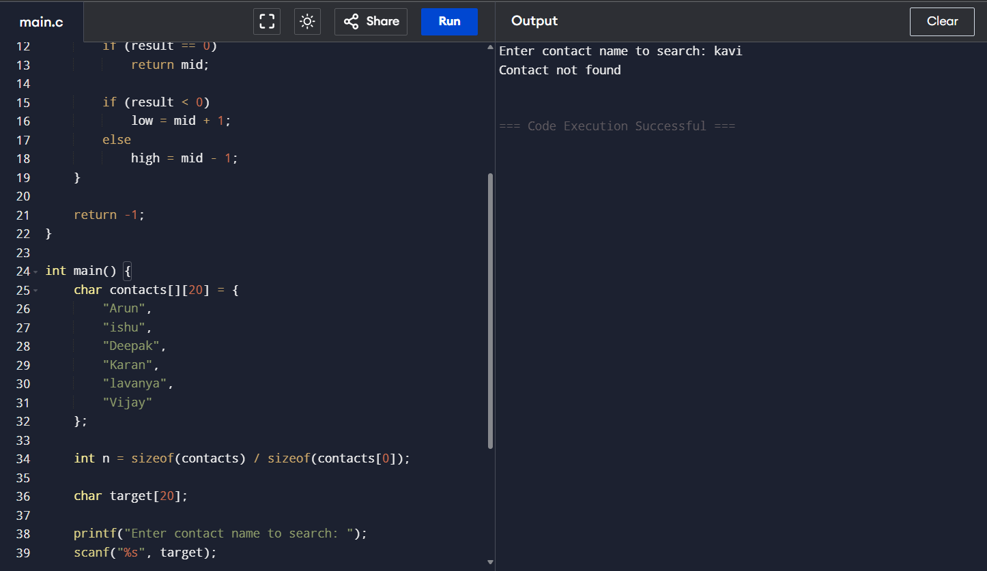
Analysis
- Best Case: O(1)
- Average Case: O(log n)
- Worst Case: O(log n)
Binary Search divides the contact list into two halves at each step until the required contact is found.
Documentation
- Programming Language: C
- Compiler: GCC / Code::Blocks / Dev C++
- Algorithm Used: Binary Search
- Data Structure: Array
Conclusion
Binary Search is suitable for searching contacts in a mobile application because it provides fast search results and reduces the search time significantly. It requires the contacts to be stored in sorted order and follows the divide-and-conquer approach for efficient searching.

